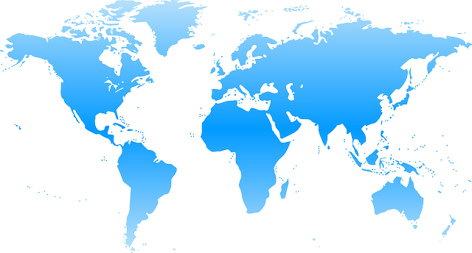
World Climate Agreement

DATE: _________________________________________________
LOCATION: ____________________________________________
ASSOCIATION (if any): __________________________________

This template was created in collaboration with the international student Think & Do Tank CliMates for the COP in MyCity project. World Climate facilitators can use it to gather all delegation commitments into one common agreement signed by participants.
Once you’ve run the World Climate Exercise and filled this sheet, please send it to CliMates at copinmycity@climates.fr and Climate Interactive at info@climateinteractive.org.
PREAMBLE
The Conference of the Parties,

Recalling the ultimate objective of the UN Climate Convention, which is to "prevent dangerous human interference with the climate system”;

Affirming the principle of common but differentiated responsibilities and respective capabilities, in the light of national contexts;

Stressing the severe climate impacts already being experienced, such as rising temperatures, disruption of rainfall cycles, and rising sea levels, which disproportionately affect particularly vulnerable countries;

Highlighting the major risks to human populations that could result in the internal and cross-border displacement of over 200 million people by 2050;

Reaffirming the international target established in the Paris Agreement (2015), to limit temperature to well below 2°C above pre-industrial levels and to strive for 1.5°C;

Emphasizing the urgent need to scale up climate finance, with developed countries leading the effort to mobilize at least $300 billion per year for the benefit of the most vulnerable countries;

Recalling the adoption of the Paris Agreement and its legally binding framework for all Parties to communicate and maintain successive Nationally Determined Contributions (NDCs) that reflect their highest possible ambition;

Decides:

Mitigation of climate change

A. Levels of Greenhouse Gas (GHG) emission reduction

PARTIES | Year GHG emissions stop growing | Year GHG emissions start reducing | Annual rate of GHG emission reduction
Annex I countries
USA
EU
Other developed countries
Non-Annex I countries
China
India
Other developing countries

Parties commit to implement actions to reduce greenhouse gas (GHG) emissions in order to fulfill the objectives described above.

B. Consequences on the climate system

According to projections based on the C-ROADS model from Climate Interactive, the fulfillment of these objectives will lead to a mean global warming of [ _____ °C] by 2100, a mean global sea level rise of [ _____ m] and a mean global acidification of oceans by [ _____ pH] by the end of the 21st century.

Forestry Land Use
A. Forest - fighting deforestation

Policies to stop deforestation (1: BAU, 0: maximum fight against deforestation) | Group A  0 - 0.3 | Group B  0.4 - 0.6 | Group C  0.7 - 1
PARTIES | List of Parties | List of Parties | List of Parties

B. Forest - promoting reforestation and afforestation

Afforestation  (1: maximum effort;  0: no afforestation) | Group A  1 - 0.7 | Group B  0.6 - 0.4 | Group C  0.3 - 0
PARTIES | List of Parties | List of Parties | List of Parties

Finance

A. Commitments

Parties with the capacity to contribute funding commit to securing financing to support Parties with concerns about poverty and/or vulnerability. Those Parties that request funding also indicate their need:

Contributors to the Fund | Amount in billions $/yr | Beneficiaries to the Fund | Amount in billions $/yr
TOTAL |  | TOTAL

B. Financing mitigation to climate change

Parties decide that _____ % of the Green Climate Fund will be allocated to climate change mitigation programs.

C. Financing adaptation to climate change

Parties decide that _____ % of the Green Climate Fund will be allocated to climate change adaptation programs.

Allocated funds will go proprietarily to the three following programs:
- _________________________________________________

- _________________________________________________

- _________________________________________________

Other commitments by Parties (other topics)

Signatures of the Parties

Representing United States of America

Representing European Union

Representing Peoples Republic of China

Representing Republic of India

Representing Other Developing Countries

Representing Other Developing Countries

