The Climate Leader Workbook
This workbook is designed to complement the video lessons of Climate Interactive’s Climate Leader training series. Use the prompts below to deepen your understanding of key concepts.

What is a system?
Wherever you are right now, look around and see how many systems you can identify that you care about. List three examples of systems or take pictures of them. Add a few sentences about what makes it a system and why you care about it.

Choose a headline from a news website that provides an example of how the connections of a system shape its behavior and take a screenshot. Write a few sentences explaining how interconnections cause the behavior described in the headline.

Write a few sentences about a way you could change the connections in a system you are part of to improve it. For example, you could provide one part of the system with better information, such as the energy use of a device in your office.

The Whole System
Write about an example of a time when you or someone else were caught up focusing on one part of the system and, as a result, misunderstood what was really going on.

Iceberg Thinking
Fill out the Iceberg Worksheet below with an example from your work.
Another way to deepen your understanding of the “Iceberg” principle is to read the classic essay “Leverage Points – Places to Intervene in a System” and slinky story by Donella Meadows.
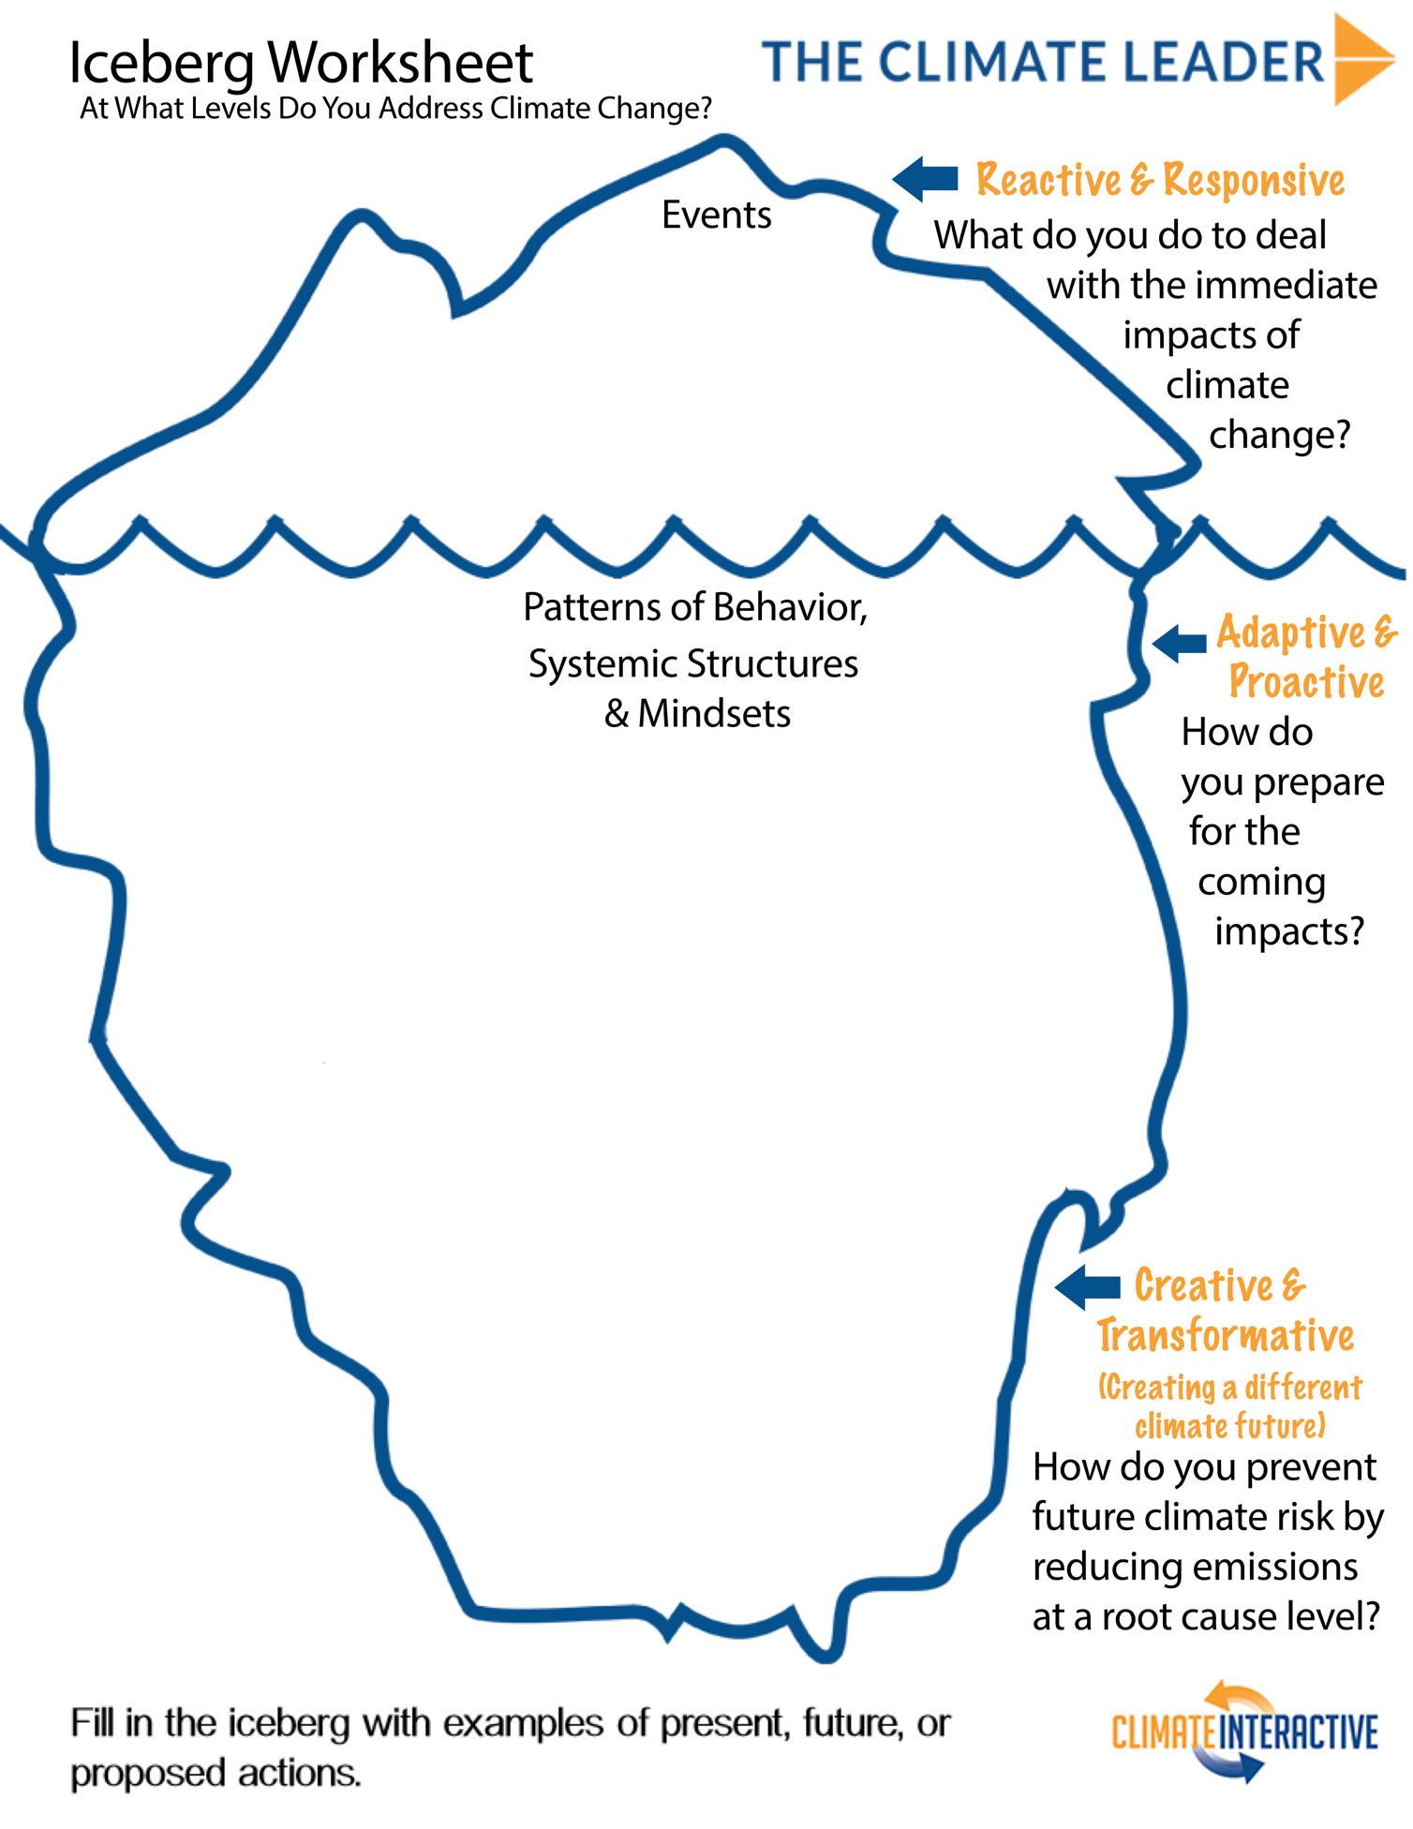
Reinforcing Feedback Loops
Name some things in your life that are increasing or decreasing due to reinforcing feedback. Try drawing the interconnections using causal diagramming.

Read this classic essay by Donella Meadows, “Nothing So Powerful as an Exponential Whose Time has Come.”

Reinforcing Feedback Loops and Climate Change
Climate change itself can cause more climate change – where some warming can result in more warming. For example, when warming causes a loss in arctic sea ice, the sun’s heat is absorbed by dark ocean water, causing even more warming.
- Tell the story in the paragraph above in a feedback loop. (Hint – if you trace all the way around the loop, warming should result in more warming).

- Connect one of the feedback loops in the video lesson with this one.

- Think about what your loops tell you about the urgency of human action on climate change and use these loops to explain the urgency to someone else.

Stocks and Flows
Redraw the credit card example from the video lesson with the feedback loop including interest payments.

Try out these three exercises created by MIT Professor John Sterman:
- Department Store Dynamics
- Bathtub Dynamics
- Climate Change Dynamics
Using the variables below related to forest management, identify which are stocks and which are flows. Then create a diagram including all the variables and feel free to add any that are not mentioned.
- Harvesting
- Middle-aged Trees
- Harvestable Sawtimber
- Aging into Sawtimber
- Seeding
- Saplings
- Aging into Middle-aged
- Deaths

Diagram:

Using the variables below related to oil recovery, identify which are stocks and which are flows. Then create a diagram including all the variables and any additional ones you need. This exercise was developed by MIT Professor John Sterman.
- Petroleum reserves
- Production rate
- Discovery rate
- Undiscovered petroleum resources
- Cumulative petroleum consumption

Diagram:

